**Project Design Phase-II**

**Data Flow Diagram & User Stories**

**TEAM ID :** PNT2022TMID53603

**PROJECT NAME** : IOT-BASED SAFETY GADGET FOR CHILD SAFETY MONITORING AND NOTIFICATION

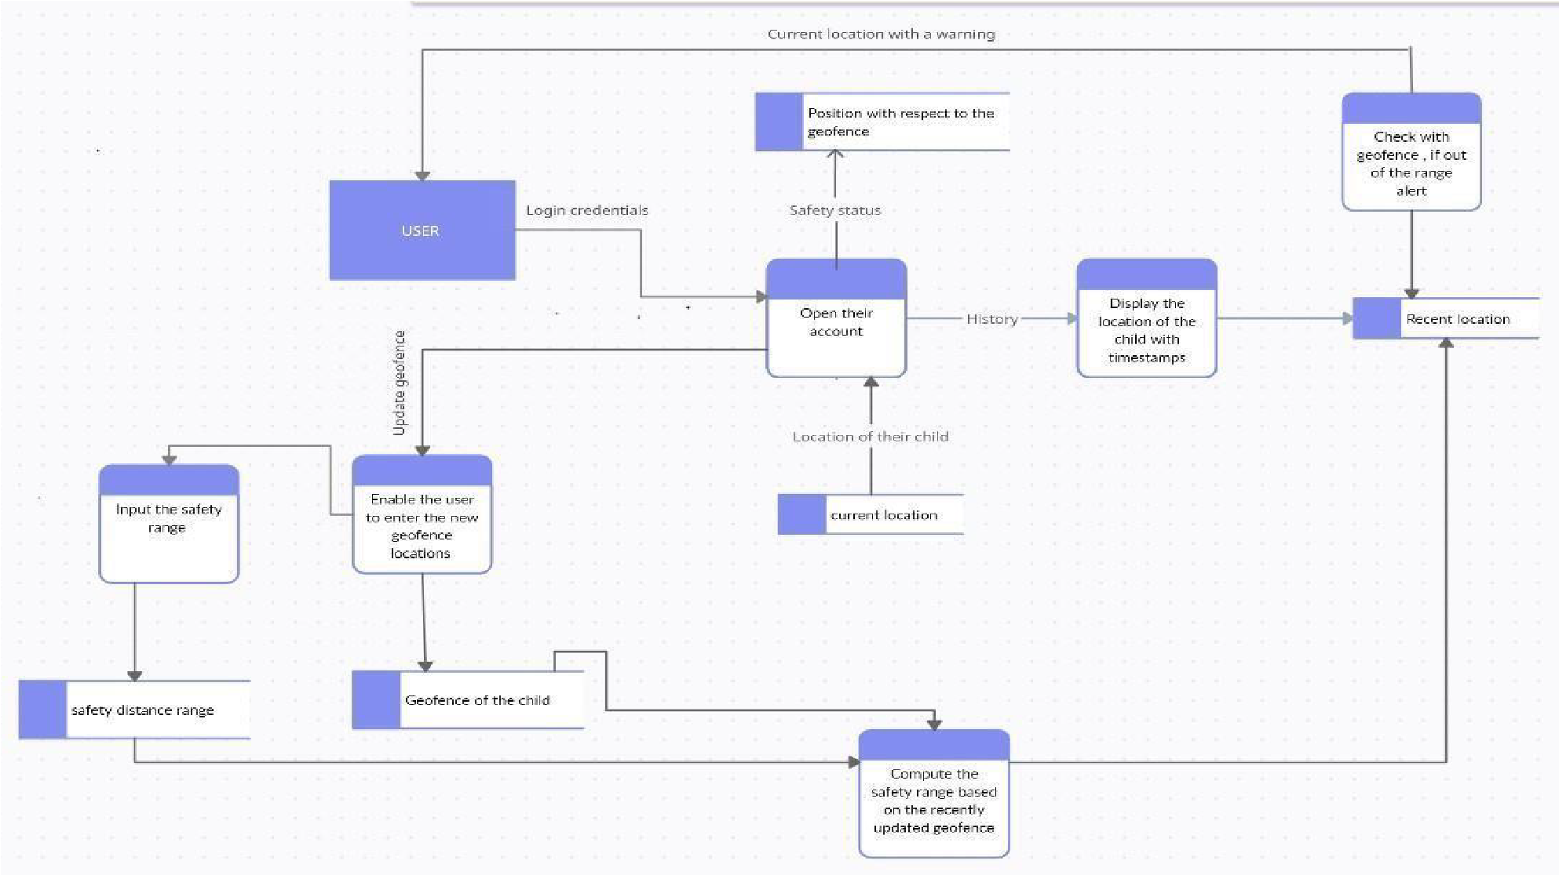**Data Flow Diagrams:**

**USER STORIES:**

Use the below template to list all the user stories for the product.

|  |  |  |  |  |  |  |
| --- | --- | --- | --- | --- | --- | --- |
| **User Type** | **Functional**  **Requirement**  **(Epic)** | **User**  **Story**  **Number** | **User Story / Task** | **Acceptance criteria** | **Priority** | **Release** |
| Customer (Mobile user) | Registration | USN-1 | As a user, I can register for the application by entering my email, password and confirming my password. | I can access my account/dashboard | High | Sprint-1 |
|  | Confirmation | USN-2 | As a user, I will receive a confirmation email once I have registered for the application | I can receive confirmation email & click confirm | High | Sprint-1 |
|  |  | USN-3 | As a user, I can register for the application through Facebook | I can register & access the dashboard with  Facebook Login | Low | Sprint-2 |
|  |  | USN-4 | As a user, I can register for the application through Gmail | I can register & access the dashboard with a Gmail account Login | Medium | Sprint-1 |
|  | Login | USN-5 | As a user, I can log into the application by entering my email & password | I can receive a Verification Mail and Verify it. | High | Sprint-1 |
|  | Dashboard | USN-6 | As a User, I can Navigate to the Dashboard after successfully Login to the Application. | I can view the locations which are accumulated in the database and other options available on the Platform via the dashboard | High | Sprint-2 |
| Customer (Web user) | Notification | USN-7 | As a user when there is an anomalous situation with the child, a notification will be received through the fencing application. | An alert message is sent to the parent's mobile and received if the user is engaged in the fencing application. | High | Sprint-1 |
| Customer Care  Executive | Support | USN-8 | As a User, I can connect with experts to clear Queries, they assist to overcome challenges by scanning for any glitches and monitoring the operation and by checking if all the users are authorized. | I can login with my given credentials to chat/call them and get clarity about any intricacies. | Medium | Sprint - 3 |
| Administrator | Login | USN-9 | As an Administrator, I can set the Geofence Location Limit and make sure the database encompassing the locations is secure, factual and updated constantly. | I can log in with my provided credentials and can exploit the prospects Open on the  Dashboard. | High | Sprint - 3 |